Chapter 10. Trunking with Multiprotocol Over ATM
This chapter covers the following key topics:
Why Two ATM Modes?—
Describes the relationship between LANE and MPOA, and discusses the choices of when to use one as opposed to the other.
MPOA Components and Model—
Provides an overview of MPOA including the various components defined and utilized by MPOA, their relationship with each other, and how they interact to support MPOA. Various traffic flows for management and user data are also described.
MPOA Configuration—
Details the commands to enable MPOA on an MPOA-capable Catalyst LANE module and on a Cisco MPOA-capable router. This details the configuration for both the Multiprotocol Server (MPS) and the Multiprotocol Client (MPC).
Sample MPOA Configuration—
This section puts it all together, and shows a sample network and the supporting MPOA configurations.
Troubleshooting an MPOA Network—
Offers guidelines for getting MPOA functional. It provides steps for ensuring that the MPOA components are operational, and provides insight for using MPOA debug.
Catalysts rarely stand alone. More often than not, they interconnect with other Catalysts. Chapter 8, "Trunking Technologies and Applications," discussed various methods for interconnecting Catalysts. Methods range from multiple links with each dedicated to a single VLAN, to a variety of trunk technologies. Fast Ethernet, Gigabit Ethernet, FDDI, and ATM technologies are all suitable for trunking Catalysts. Within ATM, you can use LAN Emulation (LANE) or Multiprotocol over ATM (MPOA) data transfer modes to trunk Catalysts. Chapter 9, "Trunking with LAN Emulation," described that option. This chapter focuses on (MPOA) in a Catalyst environment, specifically, when to use MPOA, its components, and configuring and troubleshooting MPOA.

Why Two ATM Modes?
Two modes exist for geographic scalability and efficiency. LANE emulates a local-area network and creates many virtual circuits to support each LAN Emulation Client (LEC) in each Emulated LAN (ELAN). Each LEC maintains four virtual circuits to retain ELAN membership. Two are point-to-point connections (one to the LAN Emulation Server [LES] and one to the broadcast and unknown server [BUS]), and two are point-to-multipoint connections (one from the LES and one from the BUS). The LEC connects as a leaf for the point-to-multipoint connection, with the LES and BUS as roots. An ELAN with 100 LECs then has 200 point-to-point connections, and 200 leaf node connections just for the control virtual circuits to maintain VLAN membership.
This scenario does not even count the data direct connections required for data transfers between LECs. Clearly, many more connections can be present in the ELAN to support peer-to-peer communications.
If LECs for an ELAN are geographically dispersed in a campus or enterprise network, the connections can consume a lot of virtual circuits in many ATM switches. And, if the user leases ATM services, they can be billed for each circuit established in the system. From a technical point of view, there are no limitations on the LEC distribution. But practically, LECs within an ELAN should reside in geographically limited areas to reduce the number of virtual circuit resources consumed in the ATM switches throughout the network.
Further, consider what happens when a LEC in one ELAN needs to communicate with a LEC in another ELAN. The traffic must pass through a router because each ELAN defines a unique broadcast domain. ELANs interconnect through routers, just like VLANs.
Frames traveling from a source LEC in one ELAN to a destination LEC in a second ELAN must traverse routers, as discussed in Chapter 9. If a frame passes through multiple routers to get from the source LEC to the destination LEC, multiple data direct circuits must be established so routers can pass the frame from one ELAN to another. A source LEC must establish a data direct circuit to its default gateway, another data direct must be established from that router to the next router, and so on to the final router. The last router must establish a data direct to the destination LEC. Consider the network in Figure 10-1. When an Ethernet frame from VLAN 1 (destined for VLAN 2) hits the switch, the switch LEC segments the frame into cells and passes it to the default router LEC (Router 1). The default router LEC reassembles the cells into a frame, and routes it to the LEC on the next ELAN. This LEC segments the data and forwards the frame (cells) to the next hop router LEC (Router 2) over ATM. When the cells hit Router 2's ATM interface, Router 2 reassembles the cells, routes the frame, and then segments the frame before it can pass the frame to Router 3. Router 3 reassembles the cells, routes the frame, segments the frame into cells, and forwards them to the destination Catalyst. This Catalyst reassembles the cells into a frame and passes the frame onto the destination Ethernet segment.

Figure 10-1 A Multi-ELAN Network Data Flow
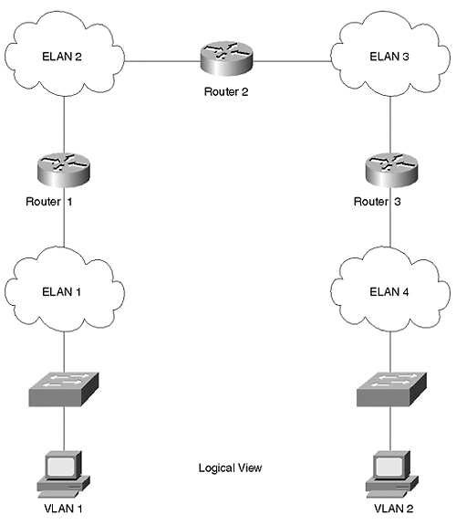
Each hop through a router introduces additional latency and consumes routing resources within each router. Some of the latency stems from the segmentation/reassembly process. Another latency factor includes the route processing time to determine the next hop. This element can be less significant in routers that do hardware routing (as opposed to legacy software-based routers).
The hop-by-hop approach was necessary when networks interconnected with shared media systems such as Ethernet. Physical connections force frames to pass through a router whenever a device in one network wants to connect to a device in another network. LANE maintains this model. It honors the rule that devices in different networks must interconnect through a router. MPOA, however, creates a virtual circuit directly between two devices residing in different ELANs.
MPOA, in fact, bypasses intermediate routers but gives the appearance that traffic from a device in one ELAN passes through routers to reach the destination device in another ELAN.
To get from one VLAN to another over ATM can require communication across several ELANs. The following sections compare how traffic flows within an ELAN as opposed to when it needs to cross more than one ELAN.

Intra-Subnet Communications
When Catalysts need to communicate with each other within the same ELAN, the Catalysts use LANE. Intra-subnet (or intra-ELAN) communications occur whenever devices in the same broadcast domain trunk to each other. The Catalyst LANE module was exclusively designed to support LANE operations with high performance to handle flows at LAN rates.
Details for intra-subnet communications are described in Chapter 9.

Inter-Subnet Communications
As discussed earlier, occasions arise where hosts in different VLANs need to communicate with each other over ATM. VLANs have similarities to ELANs on the ATM network. VLANs describe broadcast domains in a LAN environment, whereas ELANs describe broadcast domains in an ATM environment. Whenever hosts in one VLAN need to communicate with hosts in another VLAN, the traffic must be routed between them. If the inter-VLAN routing occurs on Ethernet, Multilayer Switching (MLS) is an appropriate choice to bypass routers. If the routing occurs in the ATM network, MPOA is a candidate to bypass routers. MLS and MPOA both have the same objective: to bypass routers. One does it in the LAN world (VLANs), the other does it in the ATM world (ELANs).
This chapter details the inter-VLAN/inter-ELAN communications performed with MPOA. Without MPOA, the traffic follows the hop-by-hop path described earlier in the chapter.

MPOA Components and Model
Various components comprise an MPOA system. The following sections describe each of the significant components. Figure 10-2 illustrates the components and their positional relationship. Note that there are ingress and egress devices, inbound and outbound flows, and configuration, control, and data flows.

Figure 10-2 MPOA Model
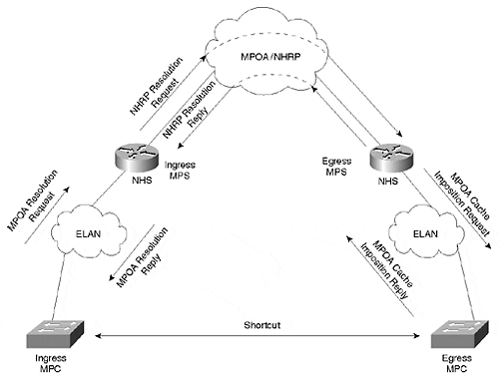
Note also the presence of LANE components. MPOA depends upon LANE for intra-ELAN communications. Communication between a Multiprotocol Client (MPC) and a Multiprotocol Server (MPS) occurs over an ELAN. Communication between adjacent Next Hop Servers (NHSs), another MPOA component discussed later in the section on Next Hop Resolution Protocol (NHRP), also occurs over ELANs. Finally, MPSs also communicate over ELANs. Additionally, if frames are sent between MPCs before a shortcut is established, the frames transit ELANs. The objective of MPOA is to ultimately circumvent this situation by transmitting frames over a shortcut between MPCs. However, the shortcut is not immediately established. It is the responsibility of the ingress MPC to generate a shortcut request with the egress MPC as the target. The ingress MPC request asks for the egress MPC's ATM address from the ingress MPS. The ingress MPS receives the shortcut request from the ingress MPC and resolves the request into a Next Hop Resolution Protocol (NHRP) request. NHSs forward the request to the final NHS, which resides in the egress MPS. The egress MPS resolves the request, informs the egress MPC to expect traffic from the ingress MPC, and returns the resolution reply to the ingress MPC.
In this process, three kinds of information flows exist: configuration, inbound/outbound, and control.
MPOA components acquire configuration information from the LECS. LANE version 2 defines this configuration flow. Both the MPC and the MPS can obtain configuration parameters from the LECS. Alternatively, they can get configurations from internal statements.
Inbound and outbound flows occur between the MPCs and the MPSs. The inbound flow occurs between the ingress MPC and MPS, whereas the outbound flow occurs between the egress MPC and MPS. Inbound and outbound are defined from the perspective of the MPOA cloud.
MPOA defines a set of control flows used to establish and maintain shortcut information. Control flows occur over ELANs between adjacent devices. Control flows as defined by MPOA include:
- MPOA Resolution Request—
Sent from the ingress MPC to the ingress MPS.
- MPOA Resolution Reply—
Sent from the ingress MPS to the ingress MPC.
- MPOA Cache Imposition Request—
Sent from the egress MPS to the egress MPC.
- MPOA Cache Imposition Reply—
Sent from the egress MPC to the egress MPS.
- MPOA Egress Cache Purge Request—
Sent from the egress MPC to the egress MPS.
- MPOA Egress Cache Purge Reply—
Sent from the egress MPS to the egress MPC.
- MPOA Keep-Alive—
Sent from an MPS to an MPC.
- MPOA Trigger—
Sent from an MPS to an MPC. If an MPS detects a flow from an MPC, the MPS issues a request to the MPC to issue an MPOA resolution request.
- NHRP Purge Request—
Sent from the egress MPC to the ingress MPC.
- NHRP Purge Reply—
Sent from the ingress MPC to the egress MPC.
Another approach to describe the control flows categorizes the flows by the components that exercise the flow. Flows between an MPC and an MPS manage the MPC cache. These include the MPOA resolution request/reply and the MPOA cache imposition request/reply. The MPC/MPS control flows communicate over the common ELAN.
Control flows between MPCs include the MPOA egress cache purge request and reply. This control flow occurs over the shortcut, which normally carries only user data. It is used to eliminate cache errors in the ingress MPC. When the egress MPC detects errors, it sends the purge request to the ingress MPC, forcing the ingress MPC to reestablish its cache information.
Control flows also exist between MPSs. However, these are defined by the internetwork layer routing protocols and NHRP. MPOA does not define any new control flows between MPSs.
The control flow list does not define the actual sequence of the messages. Figure 10-3 shows two MPCs and MPSs interconnected in an ATM network.

Figure 10-3 Control Flow Sequence in an MPOA System
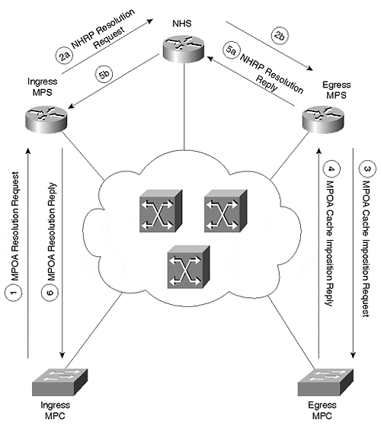
The message sequence occurs as follows:
- The ingress MPC sends an MPOA resolution request to the ingress MPS.
- The ingress MPS translates the request into an NHRP request that gets forwarded toward the egress MPS.
- The egress MPS issues an MPOA cache imposition request to the egress MPC.
- The egress MPC responds back to the egress MPS with an MPOA cache imposition reply.
- The egress MPS returns an NHRP resolution to the ingress MPS.
- The ingress MPS sends an MPOA resolution reply to the ingress MPC.

MPS
The Multiprotocol Server (MPS) interacts with NHRP on behalf of the Multiprotocol Client (MPC). An MPS always resides in a router and includes a full NHS. The MPS works with the local NHS and consults the local routing tables to resolve shortcut requests from an MPC. Figure 10-4 illustrates the components of an MPS.

Figure 10-4 MPS Anatomy
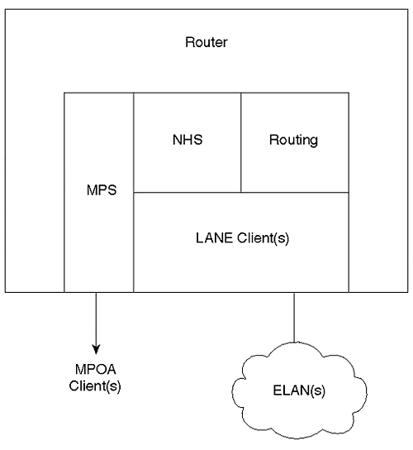
The MPS has a set of interfaces attached to the ATM cloud and at least one interface for internal services. The external connections pointing to the ATM cloud consist of LANE client(s) and an MPS interface. The LANE clients support the MPOA device discovery protocol described later, and the actual flow of data before the shortcuts are established. The MPS also uses the LEC to forward resolution requests to the next NHS in the system. The service interface interacts with internal processes such as the router processes and the NHS to facilitate MPOA resolution requests and replies.
When an MPC detects an inter-ELAN flow, the ingress MPC issues a shortcut request to the MPS asking if there is a better way to the target MPC. The ingress MPS translates the MPC's request into an NHRP request, which is forwarded to the egress MPS. The egress MPS resolves the request and performs a couple of other activities. These activities include cache imposition to the egress MPC and resolution reply back toward the ingress MPC.

MPC
In most cases, an MPC detects an inter-ELAN flow and subsequently initiates an MPOA resolution request. The MPC detects inter-ELAN flows by watching the internetwork layer destination address. When the destination and source network addresses differ, the MPC identifies a candidate flow. The MPC continues to transmit using hop-by-hop Layer 3 routing. But, it counts the number of frames transmitted to the target. If the frame count exceeds a threshold configured by the network administrator (or default values), the MPC triggers an MPOA resolution request to an appropriate MPS. The threshold is defined by two parameters: the number of frames sent and the time interval.
When the ingress MPC receives a resolution reply from the ingress MPS, the MPC can then establish a shortcut to the target MPC. Additional frames between the ingress and egress MPCs flow through the shortcut bypassing the routers in the default path.
MPOA identifies two types of MPC devices: a host device and an edge device. They differ in how they originate data in the MPOA system. The sections that follow discuss these two types of MPOA devices in greater detail.

MPOA Host Devices
Host devices originate traffic to traverse the MPOA network. A typical example of an MPC host device includes a workstation with an ATM network interface card (NIC), and MPOA drivers. An MPOA Host, then, includes at least one MPC, at least one LEC, and an internetworking layer protocol stack. An MPOA host generates traffic on its own behalf. Figure 10-5 shows an MPOA Host logical representation.

Figure 10-5 MPOA Host Device Anatomy
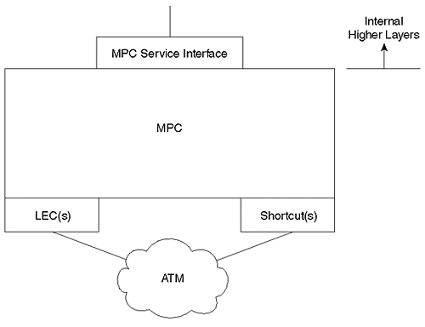
Like the MPS, the MPC host device has internal and external interfaces. The external interfaces include the LEC and the MPC. The MPC communicates to the LES through the LEC to detect MPOA neighbors. Also, traffic transmissions that are initiated before a shortcut is established will pass through the LEC.
The MPC interface, on the other hand, is used for shortcuts. When the MPC detects a flow, it issues a resolution request through its MPC interface. The MPC receives the resolution reply through the MPC interface too. After the MPC establishes a shortcut, the MPC interface becomes the origination point of the data circuit to the other MPC.
When you enable MPOA, all outbound traffic is forced through the MPC, whether or not a shortcut exists. The MPC internal service interface accepts the host's outbound traffic and passes it through the MPC. This enables the MPC to watch for flows so that shortcuts can be established as needed.

MPOA Edge Devices
Edge devices inject traffic into an MPOA system on behalf of non ATM-capable devices. As such, edge devices integrate at least one MPC, at least one LEC, and a bridge port. Bridges, LAN switches, and routers represent typical edge devices. Figure 10-6 illustrates an MPOA edge device logical representation.

Figure 10-6 MPOA Edge Device Anatomy
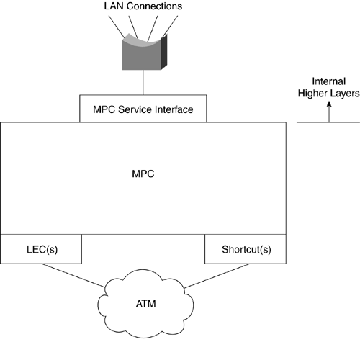
The MPC edge device is nearly identical to the MPC host device, except that its service interface connects to bridging processes. This happens because the edge device is facilitating connectivity of non-ATM capable devices onto the ATM network. These non-ATM capable devices are connected into the MPOA environment through bridged interfaces in the MPC edge device.

MPOA Operational Summary
Refer to Figure 10-7 for the following summary of data flows in MPOA.

Figure 10-7 MPOA Data Flow Summary
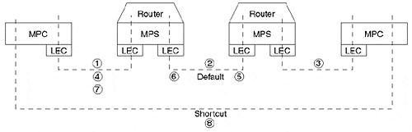
(1)Before the ingress MPC requests a shortcut, the MPC forwards frames through the LEC interface to the ATM cloud to the MPS. The MPS receives the flow on its LEC interface, performs routing and (2) forwards the frame to the next MPS. This continues until the frame reaches the egress MPS where the frame is forwarded (3) over the ELAN to the egress MPC. Until the ingress MPC establishes a shortcut, all frames pass through LECs at each device. When the ingress MPC detects a flow that exceeds the configured threshold levels (# of frames/time), the MPC issues an MPOA resolution request (4) through the MPC control interface to the ingress MPS. The ingress MPS forwards the request (5) to the next NHS which may or may not reside in an MPS. The resolution request continues to be forwarded until it reaches the device that serves as the egress MPS. Note that the resolution request propagates through LANE clients. Resolution replies propagate back to the ingress MPS (6) through LANE clients. The ingress MPS forwards the reply (7) to the ingress MPC through the MPOA control circuit. Then the ingress MPC establishes a shortcut (8) to the egress MPC. The shortcut is established to the MPC interface, not the LEC interface. Subsequent data frames stop transiting the LEC interfaces and pass through the MPC interface directly to the egress LEC.
In summary, intra-ELAN sessions flow through LANE clients, whereas inter-ELAN flows pass through the MPC interfaces.

LANE V2
In July of 1997, the ATM Forum released LANE version 2, which introduces enhancements over version 1. MPOA depends upon some of the enhancements to support MPOA operations. For example, one of the enhancements was the addition of the elan-id. MPOA uses the elan-id to identify what broadcast domains (ELANs) MPOA devices belong to. This is expected behavior in MPOA. In a non-MPOA environment, LECs use the elan-id value to filter traffic from other ELANs. If a LEC in one ELAN somehow obtains the NSAP of a LEC in another ELAN, the LEC can issue a connection request. However, because they are in different ELANs, the receiving ELAN can (and should) reject the connection request. Why? Because they are in different ELANs, they also belong to different subnetworks. A direct connection between them, then, is illegal outside of the scope of MPOA. Another LANEv2 enhancement supports neighbor discovery. When a LEC registers with the LES, it reports the MPOA device type associated with it. For example, if the LEC is associated with an MPC, the LEC informs the LES that the LEC serves an MPC. LECs associated with MPSs also report to the LES. The MPOA devices can then interrogate the LES to discover any other MPOA devices on the ELAN.

NHRP
Frequently, networks are described as having logically independent IP subnets (LISs). In legacy LANs, devices on each segment normally belong to a different IP subnet and interconnect with devices in other subnets through routers. The physical construction of the networks force traffic through the routers. In an ATM environment, a hard physical delineation doesn't exist. Connections exist whenever one ATM device requests the ATM network to create a logical circuit between the two devices. In a LAN environment, devices in the same subnet usually are located within a close proximity of each other. But in the ATM network, the devices can be located on opposite sides of the globe and still belong to the same LIS. In Figure 10-8, several LISs exist in an ATM network. But the illustration provides no hint as to the geographical proximity of devices in the system.

Figure 10-8 LISs in a Nonbroadcast Multi-Access (NBMA) Environment
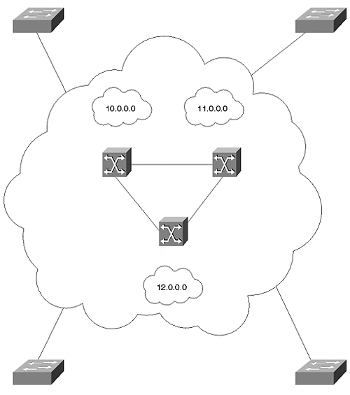
NHRP describes the attributes of each LIS in an NBMA network. Quoting RFC 2332 (NHRP):
- All members of an LIS have the same IP network/subnet number and address mask.
- All members of an LIS are directly connected to the same NBMA subnetwork.
- All hosts and routers outside of the LIS are accessed via a router.
- All members of an LIS access each other directly (without routers).
Whenever an IP station in a LIS desires to talk to another IP station in the same LIS, the source station issues an ARP request to the destination station. If the source desires to communicate with a destination in another LIS, the source must ARP for a router that is a member of at least two LISs. A router must belong to the LIS of the source device and the next hop LIS. In other words, traffic in a LIS flows hop by hop just as it does for legacy networks interconnected with Layer 3 routers. Routers must, therefore, interconnect multiple LISs to provide a Layer 3 path between networks.
NHRP identifies another method of modeling stations in an NBMA network. Logical Address Groups (LAGs) differ from LISs in that LISs forward traffic in a hop-by-hop manner. Traffic must always be forwarded to another device in the same LIS. LAGs, on the other hand, associate devices based on Quality of Service (QoS) or traffic characteristics. LAGs do not group stations according to their logical addresses. Therefore, in a LAG model, two devices in the same NBMA network can talk directly with each other, even if they belong to different LISs. MPOA shortcuts interconnect devices belonging to different LISs, creating a LAG.
NHRP works directly with routing protocols to resolve a shortcut between workstations in different LISs. The primary NHRP component to do this is the Next Hop Server (NHS) which interacts with the router to determine next hop information. Each MPS has an NHS collocated with it. The MPS translates a resolution request to an NHS request. The NHS interrogates the router for next hop information. If the destination is local, the NHS finishes its job and reports the egress information to the ingress MPS. If the destination is not local, the NHS forwards the request to the next NHS toward the destination. The NHS determines the next NHS based upon the local routing tables. It answers the question, "What is the next hop towards the destination?" The request is forwarded from NHS to NHS until it reaches the final NHS, whereupon the egress information is returned to the ingress MPS.

MPOA Configuration
Surprisingly, in spite of all of the background complexity of MPOA, configuring the MPS and MPC is quite simple. You must first have LANE configured, though. Without proper LANE configurations, MPOA never works.
Note
Before attempting to configure MPOA on your Catalyst LANE module, ensure that you have an MPOA-capable module. The legacy LANE modules do not support MPOA. The MPOA-capable modules include hardware enhancements to support the MPC functions.
Generally, the LANE module must be a model number WS-X5161, WS-X5162 for OC-12, or WS-X5167 and WS-X5168 for OC-3c support.

Although you can configure the MPOA components in any sequence, the following sequence helps to ensure that the initialization processes acquire all necessary values to enable the components.
Step 1. Configure LECS database with elan-id
Step 2. Enable LECS
Step 3. Configure MPS
Step 4. Configure MPC
Step 5. Enable LANE server and bus
Step 6. Enable LANE clients
A configuration sequence other than that listed does not prevent MPOA from functioning, but you might need to restart the LANE components so that MPOA can correctly operate. Specifically, you should ensure that the LEC can acquire the elan-id from the LECs before you enable the LEC. The elan-id is used by the MPOA components to identify broadcast domain membership. This is useful when establishing shortcuts.
Cisco implementations of LANE and MPOA use a default NSAP address scheme. Chapter 9 describes the NSAP format in detail. Remember, however, that the NSAP is comprised of three parts:
- The 13-byte prefix
- The 6-byte end-station identifier (esi)
- The 1-byte selector (sel)
The show lane default command enables you to see what the NSAP address for each LANE component will be if you enable that service within that device. Cisco's implementation of MPOA also uses a default addressing scheme that can be observed with the show mpoa default command. Example 10-1 shows the output from these two commands.

Example 10-1 LANE and MPOA Component Addresses
router#show lane default interface ATM1/0: LANE Client: 47.009181000000009092BF7401.0090AB165008.** LANE Server: 47.009181000000009092BF7401.0090AB165009.** LANE Bus: 47.009181000000009092BF7401.0090AB16500A.** LANE Config Server: 47.009181000000009092BF7401.0090AB16500B.00 note: ** is the subinterface number byte in hex router#show mpoa default interface ATM1/0: MPOA Server: 47.009181000000009092BF7401.0090AB16500C.** MPOA Client: 47.009181000000009092BF7401.0090AB16500D.** note: ** is the MPS/MPC instance number in hex
Note that the esi portion highlighted in italics of the MPS and MPC NSAP continue to increment beyond the esi portion of the LECS NSAP address. The selector byte, however, does not correlate to a subinterface as happens with the LANE components. Rather, the selector byte indicates which MPS or MPC sources the traffic. A host, edge device, or router can have more than one MPC or MPS enabled. The selector byte identifies the intended device.

Configuring the LECS Database with elan-id
In addition to the LECS configuration statements necessary to enable LANE, another database statement must be present to enable the MPOA servers and clients to identify their membership in a broadcast domain. Each broadcast domain (ELAN) in the ATM domain must be uniquely identified with a numerical ELAN identifier value. The elan-id value is a 4-octet value. Every LEC in an ELAN must have the same elan-id. Every ELAN serviced by the LECS must have a unique elan-id. Because the MPC and MPS must associate with a LEC, the MPC and MPS have an elan-id by association. They have the elan-id of the LEC.
The syntax to identify the ELAN is as follows:

name elan_name elan-id id

Example 10-2 shows how to configure the LECS database for MPOA.

Example 10-2 LECS Database Configured for MPOA
lane database usethis name elan1 server-atm-address 47.009181000000009092BF7401.0090AB165009.01 ! The elan-id number identifies the broadcast domain name elan1 elan-id 101 name elan2 server-atm-address 47.009181000000009092BF7401.0090AB165009.02 ! Each ELAN must have a unique elan-id name elan2 elan-id 102
Every ELAN with MPC components must have an elan-id assigned to it. In Example 10-2, two ELANs are defined, elan1 and elan2, each with a unique elan-id of 101 and 102, respectively. The actual value used does not matter, so long as the value is unique to the ATM domain.
Rather than letting the LECs obtain the elan-id value from the LECS, you can manually configure the elan-id value in each of the LECs in your network. But this can become administratively burdensome and is not, therefore, a widely used approach. By having the elan-id configured in the LECS database, you simplify your configuration requirements by placing the value in one location rather than many.
Whenever a LANE client connects to the LECS as part of the initialization process, the LEC acquires the elan-id. This value is then used by the MPS and the MPC during their initialization processes, and during the shortcut establishment.
Confirm that the LEC acquired the elan-id with the show lane client command. The bold highlight in Example 10-3 indicates that the Cat-A LEC belongs to the ELAN with an elan-id value of 101. This value came from the ELAN configuration statement in the LECS database.

Example 10-3 show lane client with ELAN-ID Acquired from LECS
Cat-A#show lane client LE Client ATM0.1 ELAN name: elan1 Admin: up State: operational Client ID: 2 LEC up for 13 minutes 42 seconds ELAN ID: 101 Join Attempt: 1 HW Address: 0090.ab16.b008 Type: ethernet Max Frame Size: 1516 ATM Address: 47.009181000000009092BF7401.0090AB16B008.01 VCD rxFrames txFrames Type ATM Address 0 0 0 configure 47.009181000000009092BF7401.0090AB16500B.00 3 1 7 direct 47.009181000000009092BF7401.0090AB165009.01 4 10 0 distribute 47.009181000000009092BF7401.0090AB165009.01 6 0 38 send 47.009181000000009092BF7401.0090AB16500A.01 7 76 0 forward 47.009181000000009092BF7401.0090AB16500A.01
If you enable the LANE components before you put the necessary MPOA statements in the LECS database, the LANE components do not acquire the elan-id value. In this case, you need to restart the LEC so it reinitializes and obtains the elan-id. Without the elan-id, the MPS and MPC cannot establish neighbor relationships. Nor can the egress MPS issue a cache imposition request, as the elan-id is one of the parameters passed in the request as defined by MPOA.

Configuring the MPS
Configuring the MPS requires three categories of configuration:
- Global configurations to set MPS parameters
- Major interface configurations to enable the server
- Subinterface configurations to associate LECs with the MPS
To create a functional MPOA system, you must have an MPS at the ingress and egress points in the network to resolve MPC to MPC values.
MPSs must be created on routers to interact with NHSs and routing tables. In the Catalyst product line, you can enable an MPS on a route-switch module (RSM) if the RSM has a versatile Interface Processor 2 (VIP2) containing an ATM port adapter. You cannot enable an MPS on the LANE module.

MPS Global Configuration
You have the option to modify MPS default configuration parameters. For example, you can modify the MPS's control NSAP address to a value other than the one used by default Cisco methods.
MPOA defines several timers and default values for those timers. You can modify the defaults if you so choose. Table 10-1 shows the names and descriptions for each of the MPS configurable timers.

Table 10-1. MPS Configurable Timers
Timer Name | Timer Description
Keepalive-time | How often the MPS issues a keepalive frame to the MPC. The default value is 10 seconds. Values can range from 1 second to 300 seconds.
Keepalive-lifetime | How long the MPC should consider a keepalive valid. This should be at least three times the keepalive-time value. The default value is 35 seconds. Values can range from 3 seconds to 1000 seconds.
Holding-time | How long an MPC should retain an MPOA resolution reply. The default is 20 minutes (1200 seconds). Values can range from 1 minute to 120 minutes.
The MPS issues keepalive messages to the neighbor MPCs at a frequency defined by the keepalive-time value. This maintains the neighbor relationship between the MPC and the MPS.
Example 10-4 shows a sample global configuration for the MPS. The global configuration requires you to name the MPS. The name is only locally significant, so you can name it whatever you want. If you enable more than one MPS in the unit, they need to be uniquely named within the device.

Example 10-4 MPS Global Configuration Example
router(config)#mpoa server ? config configure it now router(config)#mpoa server config ? name name to be given to the MPS router(mpoa-server-config)#! This is a global config statement router(config)#mpoa server config name mps router(mpoa-server-config)#? MPOA server configuration mode subcommands: atm-address specify the control atm address of the MPS default Set a command to its defaults exit exit the MPOA Server config mode holding-time specify the cache entry holding time of the MPS keepalive-lifetime specify the keepalive lifetime of the MPS keepalive-time specify the keepalive time of the MPS network-id specify the network id of the MPS no Negate a command or set its defaults router(mpoa-server-config)# ! Insert optional MPS configurations here
The network-id parameter allows you to prevent shortcuts between LECs on ELANs served by one MPS and LECs on ELANs served by another MPS. By default, all MPSs belong to network-id 1. If you have two MPSs, one with a network-id of 1 and the other with a network-id of 2, LECs associated with network-id 1 cannot develop a shortcut to LECs associated with network-id 2.
Tip
Even if you elect to retain the default values, you must still enter the global configuration statement mpoa server config name MPS_server_name.

MPS Major Interface Configuration
Enabling the MPS requires one statement on the ATM major interface. Note that, although multiple MPSs can be enabled in a router, even on the same major interface, an MPS can be associated with only one hardware interface. If you have two ATM modules, you need to enable at least two uniquely named MPSs. Example 10-5 shows the configuration required on the ATM major interface. The single statement enables the MPS.

Example 10-5 MPS Major Interface Configuration Example
int a1/0 !Enables MPS component mpoa server name MPS_Server_name

MPS Subinterface Configuration
The MPS must have an LEC associated with it so the MPS can communicate with other MPOA devices in the ELAN. Although more than one MPS can be associated with an interface, you can bind an LEC to only one MPS. Example 10-6 shows how to associate an MPS with an LEC. Note that only one statement is required to do this. If you enter the lane client mpoa command before you actually enable the LEC, you receive an alert informing you of this. This is all right and can be ignored, as long as you remember to enable an LEC. Without the LEC, the MPS is operating, but incapable of supporting MPOA operations. This results from its inability to communicate with any other MPOA devices in the ELAN.

Example 10-6 MPS Subinterface Configuration Example
int a1/0.x !Associates MPS with LEC lane client mpoa server name MPS_Server_name !Create LEC lane client ethernet elan_name

Examining the MPOA Server
If you correctly configure the MPS, you should see output as shown in Example 10-7.

Example 10-7 Output from show mpoa server Command
router#show mpoa server MPS Name: mps, MPS id: 0, Interface: ATM1/0, State: up network-id: 1, Keepalive: 10 secs, Holding time: 1200 secs Keepalive lifetime: 35 secs, Giveup time: 40 secs MPS actual operating address: 47.009181000000009092BF7401.0090AB16500C.00 Lane clients bound to MPS mps: ATM1/0.1 ATM1/0.2 Discovered neighbours: MPC 47.009181000000009092BF7401.0090AB16A80D.00 vcds: 75(R,A) MPC 47.009181000000009092BF7401.0090AB16B00D.00 vcds: 77(R,A)
In Example 10-7, the MPS sees two MPC neighbors. The output displays the virtual circuits used to communicate with each of the MPCs. These circuits should not experience idle timeouts and should, therefore, remain open. The default idle timeout for Cisco equipment is 5 minutes. If the device sees no traffic on the circuit for the idle timeout value, it releases the circuit. However, by default, the MPS issues keepalives to MPCs every 10 seconds. You can modify this value, but generally you should leave the timers at the default values.
If any of the neighbors are MPSs, the display would also present their NSAP address along with the MPC addresses.

Configuring the MPC
Like the configuration tasks for the MPS, configuration of the MPC requires three categories of configuration:
- Global configurations to define MPC parameters
- Major interface configurations to enable the server
- Subinterface configurations to associate LECs with the MPC

MPC Global Configuration
From the LANE module global configuration prompt, you can specify MPC parameters to modify the default behavior. Specifically, you can change the MPCs NSAP address from the Cisco default value displayed in the show mpoa default command. You can also modify the threshold that causes the MPC to issue an MPOA resolution request to the MPS. The MPOA document specifies a default threshold of 10 frames in 1 second. If the MPC observes a flow with more than 10 frames per second between devices in two different ELANs, it issues the resolution request. You can modify the frame count and the integration period. Example 10-8 shows a sample global configuration for an MPC in a Catalyst LANE module, along with some results from the Help menu. Multiple MPCs can be enabled in your Catalyst, but each must be uniquely named and individually configured.

Example 10-8 MPC Global Configuration Example
! This is a global config statement Cat-A(config)#mpoa client config name MPC_client_name ! Insert optional MPC configurations here Cat-A(mpoa-client-config)#? MPOA client configuration mode subcommands: atm-address specify the control atm address of the MPC default Set a command to its defaults exit exit the MPOA Client config mode no Negate a command or set its defaults shortcut-frame-count specify the shortcut-setup frame count of the MPC shortcut-frame-time specify the shortcut-setup frame time of the MPC
Tip
Even if you elect to retain the default values of 10 frames per second, you must still enter the global configuration statement mpoa client config name MPC_client_name.

MPC Major Interface Configuration
As with the MPS configuration, the MPC is not enabled until you enter the mpoa client command on the major interface. Example 10-9 shows a major interface configuration to enable the client. Notice its similarity to the command to enable an MPS as in Example 10-5.

Example 10-9 MPC Major Interface Configuration Example
int a1/0 !Creates MPC function mpoa client name MPC_client_name

MPC Subinterface Configuration
Each VLAN for which you want MPOA capability must have an MPC associated with an LEC on the appropriate subinterfaces. Example 10-10 demonstrates how to build the LEC to MPC association. A three-way relationship exists in the configuration. In Example 10-10, the first lane client command enables the LEC/VLAN to participate in MPOA. The LEC associates with a VLAN 12 in the second lane client command. VLAN 12 and ELAN_name correlate to the same broadcast domain.

Example 10-10 MPC Subinterface Configuration Example
int a0.x !Associates MPC with LEC lane client mpoa client name MPC_client_name !Create LEC lane client ethernet 12 elan_name
Remember that you can bind the LEC to only one MPC. If you bind the MPC to the LEC before you enable the LEC, you receive a warning indicating that no LEC is configured. You can ignore this warning as long as you remember to eventually enable a LEC. When you complete the lane client mpoa command, you can create the LEC on the subinterface. If you create the LEC first, you can enable the MPC afterwards. In either case, make sure that the LEC acquires the elan-id.

Examining the MPOA Client
If you configure MPOA correctly, you should see output for your client as shown in Example 10-11. This output displays the MPC situation before any shortcuts are established. You can identify shortcuts when there are entries under the Remote Devices known section of the MPC output display.

Example 10-11 MPOA Client Show Output
Cat-A#show mpoa client MPC Name: mpc2, Interface: ATM0, State: Up MPC actual operating address: 47.009181000000009092BF7401.0090AB16A80D.00 Shortcut-Setup Count: 10, Shortcut-Setup Time: 1 Lane clients bound to MPC mpc2: ATM1/0.2 Discovered MPS neighbours kp-alv vcd rxPkts txPkts 47.009181000000009092BF7401.0090AB16500C.00 31 9 76 2 Remote Devices known vcd rxPkts txPkts
Suppose that you send an extended ping to an egress MPC with 20 pings in the sequence. When the ingress MPC sends enough frames to cross the shortcut threshold, it issues the shortcut request to its neighbor MPS. Assuming that the MPS resolved the shortcut, the ingress MPC can establish the shortcut and start using it rather than the default path.
But during the extended ping operation, the egress MPC sends an echo reply for each echo request issued from the ingress MPC. If the shortcut threshold is set for the same or less than for the ingress MPC, the echo replies cause the egress MPC to issue a shortcut request too. Ultimately, both the ingress and egress MPCs develop shortcuts between each other as illustrated by Example 10-12.

Example 10-12 show mpoa client Display after Shortcut
Cat-A#show mpoa client MPC Name: mpc, Interface: ATM0, State: Up MPC actual operating address: 47.000601171000008100530606.0090AB16500D.00 Shortcut-Setup Count: 10, Shortcut-Setup Time: 1 Lane clients bound to MPC mpc: ATM0.20 Discovered MPS neighbours kp-alv vcd rxPkts txPkts 47.000601171000008100530606.0090AB16B00C.00 28 35 125 4 Remote Devices known vcd rxPkts txPkts 47.000601171000008100530606.0090AB16A80D.00 49 7 8 47 0 0
The MPCs use only one of the shortcuts, though. The shortcut established by the MPC with lowest NSAP address is used by both clients. The ingress MPC of Example 10-12 has the lowest MAC address and should be the one used by the two MPCs. Issuing the show atm vc 49 command confirms that the local device originated from virtual circuit (VC) 49 (see Example 10-13).

Example 10-13 Confirm Call Origination
Cat-A#show atm vc 49 ATM0: VCD: 49, VPI: 0, VCI: 80, etype:0x0, AAL5 - LLC/SNAP, Flags: 0x50 PeakRate: 0, Average Rate: 0, Burst Cells: 0, VCmode: 0x0 OAM DISABLED, InARP DISABLED InPkts: 7, OutPkts: 8, InBytes: 724, OutBytes: 766 InPRoc: 7, OutPRoc: 8, Broadcasts: 0 InFast: 0, OutFast: 0, InAS: 0, OutAS: 0 OAM F5 cells sent: 0, OAM cells received: 0 Status: ACTIVE , TTL: 4 interface = ATM0, call locally initiated, call reference = 118 vcnum = 49, vpi = 0, vci = 80, state = Active(U10) , point-to-point call Retry count: Current = 0 timer currently inactive, timer value = 00:00:00 Remote Atm Nsap address: 47.000601171000008100530606.0090AB16A80D.00
VC 47 eventually times out and disappears. Until a device tears down the circuit, both circuits remain in place, but only one is used. Note that the traffic counters for VC 47 show zero frames sent or received. Whether or not this happens is a function of your traffic flows. Not all application/protocol flows create a one for one reply-response and will therefore only create one VC.

Sample MPOA Configuration
This section presents a sample network to summarize the configuration for MPCs and MPSs. Figure 10-9 Sample MPOA Network illustrates the network where two MPCs interconnect through one MPS.

Figure 10-9 Sample MPOA Network
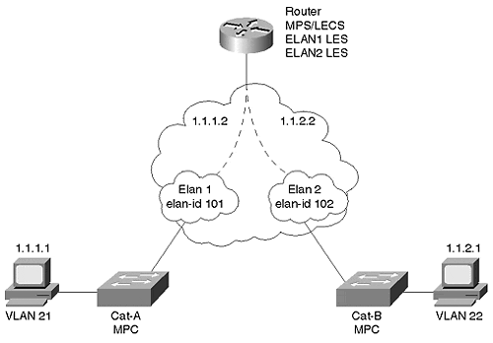
The MPCs reside inside of Catalysts equipped with MPOA-capable LANE modules. The MPS resides in a 7204 router. Each MPC has one LEC enabled. The MPS has two LECs enabled, one for each of the two ELANs. The LECS and LESs reside in the 7204 router, although it could just as easily have been configured in either of the Catalysts.
Example 10-14 shows the relevant configuration statements for Cat-A.

Example 10-14 Cat-A MPOA Configuration
! mpoa client config name mpc1 !interface ATM0 no ip address atm pvc 5 0 5 qsaal atm pvc 16 0 16 ilmi mpoa client name mpc1 ! interface ATM0.1 multipoint lane client mpoa client name mpc1 lane client ethernet 21 elan1
Similarly, Cat-B's configuration reflects Cat-A's. Note that no IP address is configured on the Catalysts because the LANE module does not let you assign one. This results from the LANE module behaving like a bridge port. Example 10-15 shows Cat-B's configuration. The MPC names differ in the two configurations (Cat-A and Cat-B), but they could be the same because the names are only locally significant.

Example 10-15 Cat-B MPOA Client Configuration
! mpoa client config name mpc2 ! interface ATM0 no ip address atm pvc 5 0 5 qsaal atm pvc 16 0 16 ilmi mpoa client name mpc2 ! interface ATM0.2 multipoint lane client mpoa client name mpc2 lane client ethernet 22 elan2
The MPS configuration of Example 10-16 resides in a router and has an IP address associated with each subinterface. Not shown in this abbreviated output, but vitally important in the configuration, is a routing protocol configuration. You must have routing enabled for the MPS/NHS to function correctly.

Example 10-16 Router MPOA Server Configuration
lane database usethis name elan1 server-atm-address 47.009181000000009092BF7401.0090AB165009.01 name elan1 elan-id 101 name elan2 server-atm-address 47.009181000000009092BF7401.0090AB165009.02 name elan2 elan-id 102 ! mpoa server config name mps ! interface ATM1/0 no ip address atm pvc 5 0 5 qsaal atm pvc 16 0 16 ilmi lane config auto-config-atm-address lane config database usethis mpoa server name mps ! interface ATM1/0.1 multipoint ip address 1.1.1.2 255.255.255.0 lane server-bus ethernet elan1 lane client mpoa server name mps lane client ethernet elan1 ! interface ATM1/0.2 multipoint ip address 1.1.2.2 255.255.255.0 lane server-bus ethernet elan2 lane client mpoa server name mps lane client ethernet elan2

Troubleshooting an MPOA Network
Troubleshooting an MPOA network is not conceptually difficult. Generically, the first step is to characterize the problem. The most likely symptom is an inability to create a shortcut. Assuming all media is intact between the source and the destination (not always a good assumption), troubleshooting consists of the following:
- Ensuring that all ELANs are functional between the source and destination.
- Determining that all MPCs and MPSs are operational.
- Determining that MPCs and MPSs discovered each other.
- Determining if the threshold is crossed at the MPC to initiate an MPOA resolution request.
- Ensuring that NHSs or MPSs exist along the default path at each hop to participate in resolution activities.
The following sections expand upon each of the troubleshooting activities listed in the preceding.

Ensuring the ELANs Are Functional between the Source and the Destination
If you configure the ELANs correctly, you should be able to ping each of the interfaces for each MPS and NHS along the default path between the source and destination client. If not, you either configured the ELAN incorrectly, you have a Layer 3 issue such as a bad IP address, or you have some routing protocol issues.
Examine your intra-ELAN connectivity first. See if you can ping the neighbor device(s) within the ELAN. If you can, ping the next device in the next ELAN, either from your current device or from the next hop component within your ELAN. Do this along each ELAN to ensure that each ELAN is completely functional.
Also ensure that each LEC bound to an MPOA device acquired an elan-id as demonstrated in the Catalyst output of Example 10-3.

Determining That All MPCs and MPSs Are Functional
Check the configuration results of the MPC and MPS with the show mpoa client and show mpoa server commands. Each command should provide you with basic information such as name of the device, the interface where it is enabled, and the current state (up or down).

Determining That MPCs and MPSs Discovered Each Other
Each MPOA device attempts to discover its MPOA neighbors through the ELAN's LES. MPOA has a neighbor discovery protocol enabling MPCs to discover MPSs, and for MPSs to discover other MPSs. Output from the show mpoa client and show mpoa server commands verify if the device knows any neighbors. The MPS and MPC discover each other by registering their device type values with the LES of their local ELAN. They then send an inquiry to the LES to discover the neighbor devices.

Determining If the Threshold Is Crossed at the MPC to Initiate an MPOA Resolution Request
MPOA defines a default value of 10 frames over 1 second as a threshold for an MPC to trigger a resolution request. If the traffic type never exceeds the configured threshold, the MPC never attempts to establish a shortcut to the egress MPC. You can get an indication if the client even issued a resolution request with the show mpoa client cache command. Example 10-17 shows client statistics for an MPC, and shows that it issued and received an MPOA resolution request and reply.

Example 10-17 An MPOA Client Statistics Screen
Cat-A#sh mp cl statistics MPC Name: mpc2, Interface: ATM1/0, State: Up MPC actual operating address: 47.009181000000009092BF7401.0090AB16A80D.00 Shortcut-Setup Count: 10, Shortcut-Setup Time: 1 Transmitted Received MPOA Resolution Requests 1 0 MPOA Resolution Replies 0 1 MPOA Cache Imposition Requests 0 1 MPOA Cache Imposition Replies 1 0 MPOA Cache Purge Requests 0 0 MPOA Cache Purge Replies 0 0 MPOA Trigger Request 0 0 NHRP Purge Requests 0 0 Invalid MPOA Data Packets Received: 0 Cat-A#
If the resolution request counter does not increment, the MPC does not see interesting traffic to trigger a request to an MPS. If the resolution request counter increments, but the resolution reply counter does not match the request counter, the MPC did not receive a reply to its request. When this happens, ensure that the MPSs are operational. Also check that a default path actually exists to the egress MPC. If the default path does not exist, the MPS cannot resolve a shortcut.
Another method of examining the MPC behavior uses debug. The debug mpoa client command provides an opportunity to track how the MPC monitors a potential flow and to determine if the MPC actually triggers an MPOA resolution request. Example 10-18 shows an abbreviated debug output from an MPC.

Example 10-18 Sample debug mpoa client Command Output
Cat-A#debug mp cl ? all Enable all MPOA Client debugging data Debugs MPOA Client Data Processing egress Debugs MPOA Client Egress Activity general Debugs MPOA Client General/Common Activity ingress Debugs MPOA Client Ingress Activity keep-alives Debugs keep-alives received from MPOA servers platform-specific Hardware platform specific debug Cat-A#debug mp cl all … … MPOA CLIENT: mpc_trigger_from_lane: mac 0090.ab16.5008 on out ATM0.20 MPOA CLIENT: Is MAC 0090.ab16.5008 interesting on i/f: ATM0.20 MPOA CLIENT MPC: MAC 0090.ab16.5008 interesting MPOA CLIENT: lower levels detected 1 packets to 0090.ab16.5008 (3.0.0.1) MPOA CLIENT MPC: mpc_ingress_cache_state_machine called for icache 3.0.0.1: current state: INIT, event MPC_ELIGIBLE_PACKET_RECEIVED MPOA CLIENT: mpc_count_and_trigger: cache state INIT MPOA CLIENT: mpc_trigger_from_lane: mac 0090.ab16.5008 on out ATM0.20 MPOA CLIENT: Is MAC 0090.ab16.5008 interesting on i/f: ATM0.20 MPOA CLIENT MPC: MAC 0090.ab16.5008 interesting MPOA CLIENT: lower levels detected 1 packets to 0090.ab16.5008 (3.0.0.1) MPOA CLIENT MPC: mpc_ingress_cache_state_machine called for icache 3.0.0.1: current state: INIT, event MPC_FLOW_DETECTED MPOA CLIENT MPC: MPOA Resolution process started for 3.0.0.1 MPOA CLIENT MPC: Sending MPOA Resol. req(ReqId=2) for 3.0.0.1 MPOA CLIENT: mpc_count_and_trigger: cache state TRIG
The first two highlighted portions of the output illustrate where the MPC recognized what is called interesting traffic. Interesting traffic targets a host in another ELAN. Therefore, the source and destination Layer 3 addresses differ. But the destination MAC address targets a neighbor ingress MPS. Why does it see a MAC address for the MPS? The MPC sees a MAC address for the MPS because this is the first router in the default path. The MPC puts the first hop router's MAC address in the data link header. The two highlighted statements are for frames 9 and 10 within the configured one-second period (the first eight frames were removed for simplicity). There is no indication of the frame count, so you might need to sort through the debug output to see if at least ten frames were seen. Because there are ten frames per second, the MPC triggers a resolution request to the ingress MPS. This is shown in the third highlighted area of Example 10-18.
Eventually, the MPC should receive a resolution reply from the MPS as shown in Example 10-19.

Example 10-19 MPOA Resolution Reply from debug
MPOA CLIENT: received a MPOA_RESOLUTION_REPLY packet of size 127 bytes on ATM1/0 vcd 832 dumping nhrp packet: fixed part: op_type 135 (MPOA_RESOLUTION_REPLY), shtl 20, sstl 0 mandatory part: src_proto_len 4, dst_proto_len 4, flags 0, request_id 2 src_nbma_addr: 47.009181000001000200030099.0090AB16540D.00 src_prot_addr: 0.0.0.0 dst_prot_addr: 3.0.0.1 cie 0: code 0, prefix_length 0, mtu 1500, holding_time 1200 cli_addr_tl 20, cli_saddr_tl 0, cli_proto_len 0, preference 0 cli_nbma_addr: 47.009181000001000200030099.0090AB164C0D.00 tlv 0: type 4097, length 4 data: 15 05 00 01 tlv 1: type 4096, length 23 compulsory data: 00 00 00 01 00 00 00 67 0E 00 90 AB 16 4C 08 00 90 AB 16 B0 08 08 00 MPOA CLIENT MPC: Resol Reply- IP addr 3.0.0.1, mpxp addr=47.00918100000100020003 0099.0090AB164C0D.00, TAG=352649217 MPOA CLIENT MPC: mpc_ingress_cache_state_machine called for icache 3.0.0.1: current state: TRIG, event MPC_VALID_RESOL_REPLY_RECVD
The middle portion of the debug output displays various items from the MPOA resolution reply messages. For example, cie refers to a client information element as specified by MPOA. code 0 means that the operation was successful. Reference the MPOA documents for decode specifics. The important parts of the debug for the immediate purposes of troubleshooting are highlighted.

Ensuring That the MPS and NHS Components ARE Functional
Check along the default path and ensure that all MPOA server related devices found each other and can communicate over LANE. Without functional pieces, MPOA cannot resolve a shortcut.

Other Causes of MPOA Failures
One other event can prevent a shortcut from getting established. When the ingress MPC issues the resolution request, the request gets forwarded to the egress MPS. The egress MPS issues a cache imposition request to the egress MPC. If the egress MPC cannot accept a cache imposition, it rejects the imposition request forcing the ingress MPC to continue to use the default paths.
The egress MPC can reject the imposition whenever its local resources prevent it from doing so. For example, the egress MPC might not have enough memory resources to hold another cache entry. It might be that the egress MPC already has too many virtual circuits established and cannot support another circuit. Any of these can cause the egress MPC to reject the imposition preventing a shortcut from getting established.
If you use the MPC debug, you should see a line like that shown at the end of Example 10-19 to confirm that the cache imposition worked successfully.

Review Questions
This section includes a variety of questions on the topic of this chapter—MPOA. By completing these, you can test your mastery of the material included in this chapter as well as help prepare yourself for the CCIE written and lab tests.
1: | A network administrator observes that the MPC cannot develop a shortcut. An ATM analyzer attached to the network shows that the MPC never issues a shortcut request, even though the 10 frames per second threshold is crossed. Why doesn't the MPC issue a shortcut request? The show mpoa client command displays as shown in Example 10-20 .  Example 10-20 Client Output for Review Question 1  Cat-C#sh mpoa client MPC Name: mpc2, Interface: ATM1/0, State: Up MPC actual operating address: 47.009181000000009092BF7401.0090AB16A80D.00 Shortcut-Setup Count: 10, Shortcut-Setup Time: 1 Lane clients bound to MPC mpc2:
2: | When might the ingress and egress MPS reside in the same router?
3: | What creates the association of an MPC with a VLAN?
4: | Example 10-6 has the following configuration statement in it: lane client ethernet elan_name. Where is the VLAN reference?
5: | If a frame must pass through three routers to get from an ingress LEC to an egress LEC, do all three routers need to be configured as an MPS?
6: | Can you configure both an MPC and an MPS in a router?

